Angela Castillo Author Visit Order Form.
Please indicate if you would like you book(s) inscribed to a certain name on the order form. All books will come autographed by the author. Books will be delivered to the school within four weeks of the ordered date. To find out more about Angela Castillo’s books, you can go to http://tobythetrilby.weebly.com or her Amazon page at https://amzn.to/30ir95o.
NAME:__________________________________ TEACHER’S NAME_____________________________
PHONE NUMBER___________________________ EMAIL_____________________________________

Book Title: | Cost | # of copies | Total | Book signed to: (Please only ONE name per book)
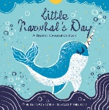  Little Narwhal’s Day  (A picture book) | 10.00 P  15.00 H
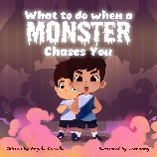  What to do When a Monster Chases You  (A goofy monster picture book) | 10:00 P  15.00 H
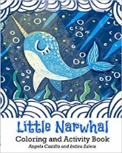  Little Narwhal Coloring  and Activity book | $5.00 P
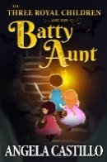  The Three Royal Children  and the Batty Aunt (Book 1)  (Chapter book for grades 2-5) | $7.00 P
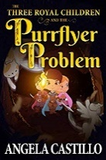  The Three Royal Children  and the Batty Aunt (book 2)  (Chapter book for grades 2-5) | $7.00 P
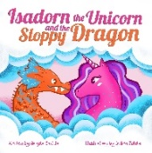  Isadorn the Unicorn and the Sloppy Dragon  (Teaches about healthy ways to solve conflicts) | 10.00 P  15.00 H
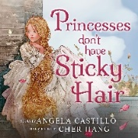  Princesses don’t have Sticky Hair.  A fun and silly bedtime story with fantasy creatures of all kinds. | 10.00 P  15.00 H
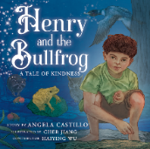  Henry and the Bullfrog  Explore the swamps of Louisiana and learn a lesson about kindness. | 10.00 P  15.00 H
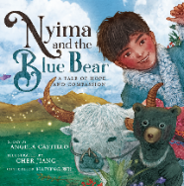  Nyima and the Blue Bear  Adventure through the mountains of Tibet in this story of hope and compassion | 10.00 P  15.00 H
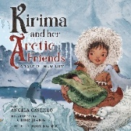  Kirima and the Narwhal  Kirima is about to have a new baby brother. Can her Arctic friends help her feel better? | 10.00 P  17.00 H
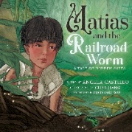  Mattias and the Railroad Worm  Mattias and his friends are stuck in a cave. Can a worm help them find their way? | 10.00 P  15.00 H
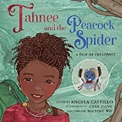  Tahnee and the Peacock Spider  Can Tahnee and Peacock Spider stay true to their own creativity? | 10.00 P  15.00 h
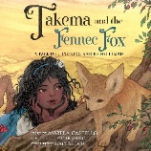  Takema and the Fennec Fox  Join Takema and her desert friends in an important lesson about listening and being heard. | 10.00 P  15.00 H
Method of payment:  Cash_____ Check___________  Paypal ___(atmadunes@aol.com) |  | TOTAL

PLEASE RETURN TO SCHOOL BY:_____________________________________________

